USA faith leaders call for diplomacy, not war, with Iran
Independent Catholic News, https://www.indcatholicnews.com/news/37458, 10 July 2019

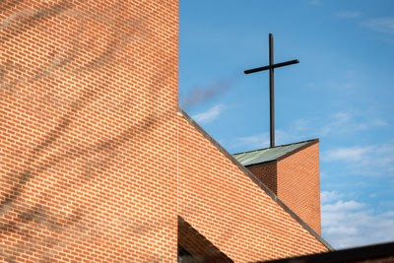Photo: Albin Hillert/WCC

Faith leaders across the USA have released a jointly signed statement today, 9 July, entitled: 'Back from the Brink: Faith leaders call for diplomacy, not war, with Iran.'
Coordinated through Sojourners, the statement describes a USA-Iran war as an unmitigated disaster as well as morally and religiously indefensible.
"Given the escalation of confrontation between the United States and Iran, it is time for leaders from our faith communities to point to more effective ways to transform conflict and to speak strongly against military action that could have enormous human and financial costs, and which could easily and broadly escalate," the statement reads. "While we agree that Iran should repudiate terrorism and not resume uranium enrichment, we stand as religious leaders to say that war is not the answer with Iran and is unjustifiable on moral and religious grounds."
The statement urges political leaders to learn from the failed policies of the past. "It is time for a different approach," reads the statement. "The United States should end its policy of harsh and punitive trade sanctions against the Iranian people."
The statement calls for a different way. "Our scriptures instruct us to avoid war and to live as peaceably as possible with all," the statement reads. "We call on all our religious leaders, theologians, clergy, and laypersons to speak out against the option of war with Iran." (Source: WCC)

