Bishops’ Interfaith Committee marks second anniversary of mosques atrocity
NZ Catholic Bishops Conference, 15 Mar 2021 https://www.catholic.org.nz

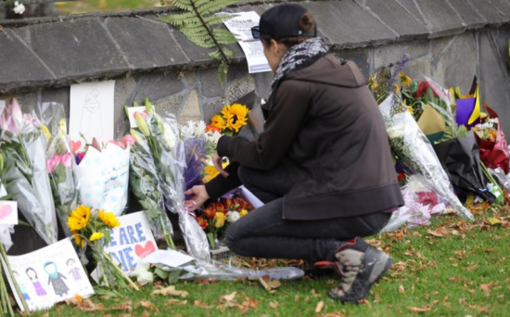

The Interfaith Relations Committee of the Catholic Bishops of Aotearoa New Zealand has sent a letter of support to the country’s Muslim communities on the second anniversary of the Christchurch mosques atrocity.
“In a spirit of peace and prayer we reach out at this time to those who live in this land, and especially the Muslim community of New Zealand,” says the letter, signed by committee chair, Colin MacLeod, who is also the director of the Church’s National Centre for Religious Studies.
“We give thanks for the diversity of deeply held religious beliefs which draw people to embrace one another with compassion, healing and hope.
“While many may hold that religious beliefs are the cause of violence, we know from our rich relationships with those of many faiths, that the choice to cause harm to others is grounded not in the divine but in other attitudes such as selfishness or fear.
“We pray to our loving God, that all violence may cease, and that diversity of faith may be seen as opportunity for dialogue through which all may be blessed.”
Fifty-one worshippers died and many more were wounded when a gunman opened fire in attacks on the Masjid Al-Noor and Linwood mosques two years ago today.
The committee’s letter has been sent to various parties, especially our Muslim brothers and sisters.

